Patient Name Date of Birth

Area of Injury/Condition
Date of Injury/Onset of Condition Date of Surgery (if applicable)
Date of Next Doctor’s Appointment?
What are your goals for physical therapy?
1.
2.
3.
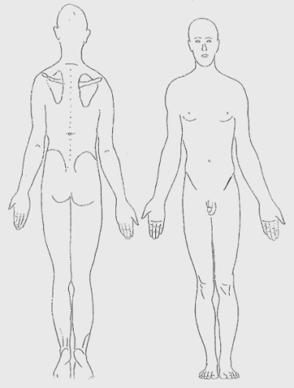
What is your perceived level of function for the involved body part
as of today? _____% (100% = body part is normal)

Please describe your pain:

Please rate your pain (1 = minimal, 10 = severe)
At its WORST: 1 2 3 4 5 6 7 8 9 10
At its BEST: 1 2 3 4 5 6 7 8 9 10

Please Mark the Area(s) of Concern
Do you currently have, or have you ever had any of the following?

High Blood Pressure NO YES Osteoporosis NO YES Pain at Night NO YES
Heart Disease NO YES Cancer NO YES Leg Swelling NO YES
Circulatory Conditions NO YES Arthritis NO YES Asthma NO YES
Seizures NO YES Diabetes NO YES Fractures NO YES
Have you noticed a significant change (gain or loss) in weight? NO YES
Have you noticed a change in your vision or hearing? NO YES
Do you have any METAL (pins, plates) in your body? NO YES
Do you have a PACEMAKER? NO YES
Do you have any allergies? NO YES
(Females only) Do you suspect that you may be pregnant? NO YES

Please list any recent diagnostic studies (MRI, x-rays, etc.)
Please list any previous surgeries you have had, please provide dates if possible:
Please list any medication you are currently taking:

Patient Signature Date

